**Preetha.A**

**Cyclistic Bike Share Analysis - Tableau**

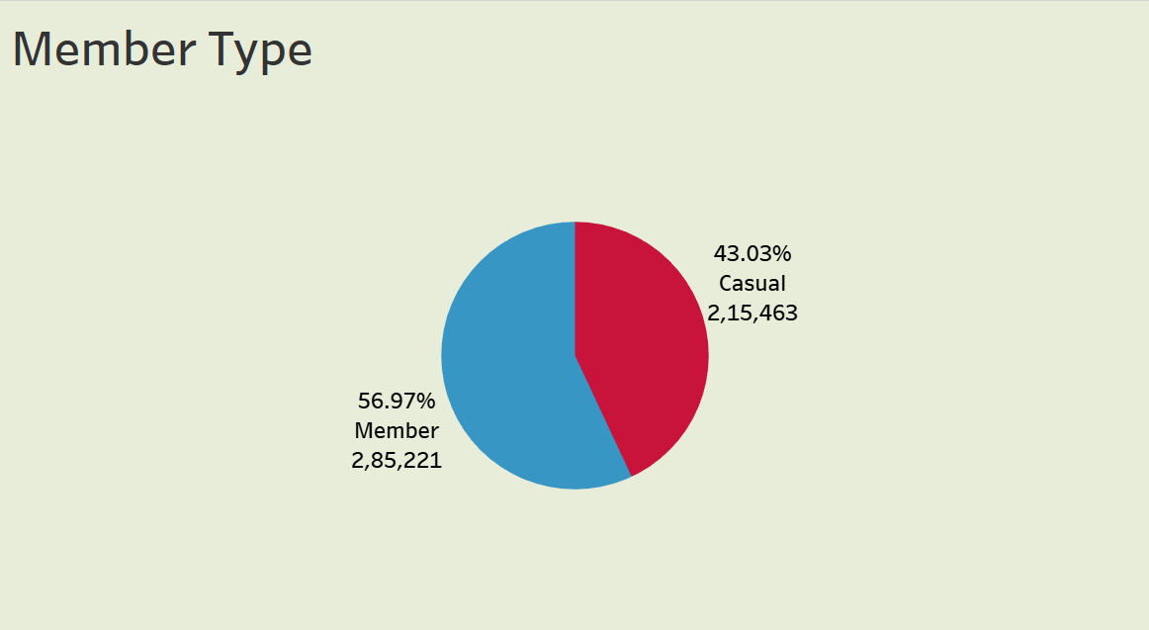

I am excited to present to you my first case study as a Data Analyst, where I worked with a realistic dataset and gained some valuable insights about the business and its customers.

**Related Links**

Github

Tableau Dashboard

**Table of Contents**

Introduction

Objective

Preparation

Process

Analysis

Conclusion

**Introduction**

I completed this Case study as a Capstone Project for the Certification.

I used datasets for one month, which were from 01-09 2020 to oct 30-09-2020. The data consists of more than 5 lakh rows and 13 Columns. I have the Ride ID, Type of bike, the start/end station names, their latitude, longitude and IDs and the Member Type (Casual or Annual), starting station, ending Station.

**Objective**

Cyclistic is a Bike Share service in Chicago. As a Junior Data Analyst, working in a Bike Sharing Company, my objective was to find how the Casual members and the Annual members use the Bike Share service differently and provide 3 recommendations on how we can covert Casual members to Annual members as Annual members are more profitable for the company.

**Tools used:**

Excel Powe Quary Editor

Tableau

**Preparation**

The first thing I did was to download the dataset, which were available in CSV format. I imported the file into Excel. It was one month dataset.

After analysing all the columns and selecting appropriate data types for them, I created a table using Power Quary Editor.

**Process**

To process the data, I first thought about the insights I wanted to gather and what data I needed to use for that. I realized that I did not need the Start/End station ID, so deleted those columns.

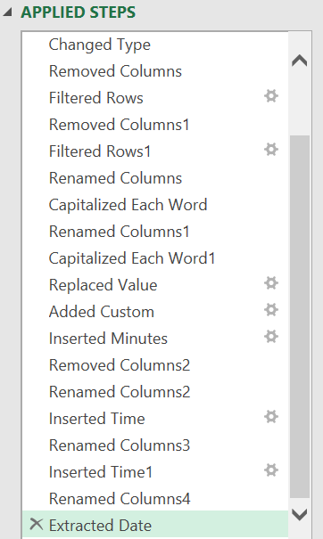

These steps are done for cleaning the Data

## **Analysis**

Here are the findings I derived from the processed data:

**This Visualization tells**

* Number of rides by week Day, rides by member Type, Rides by month, Rides by day, rides by week, the path chart tells duration of rides by day
* In this visualization when compare week days Sunday and Saturday casual member using more rides than member
* Overall percentage of month rides 43.03% -Casual, 56.97%-member

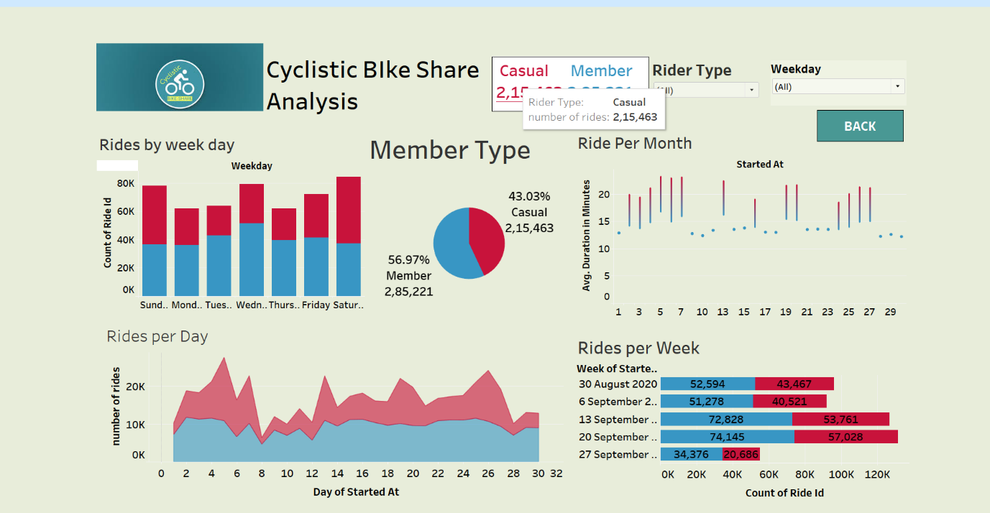

**Duration Of Rides**

* This visualization tells Ride duration by month, hours, week days
* Annual members use the bikes mostly around 8 am and 6.30 pm and on weekdays, signifying that they probably use the bikes to travel to their workplace or college.
* Casual members use the bikes mostly around 10 am to 8 pm and on weekends, suggesting that they use the bikes for recreation in the evenings.

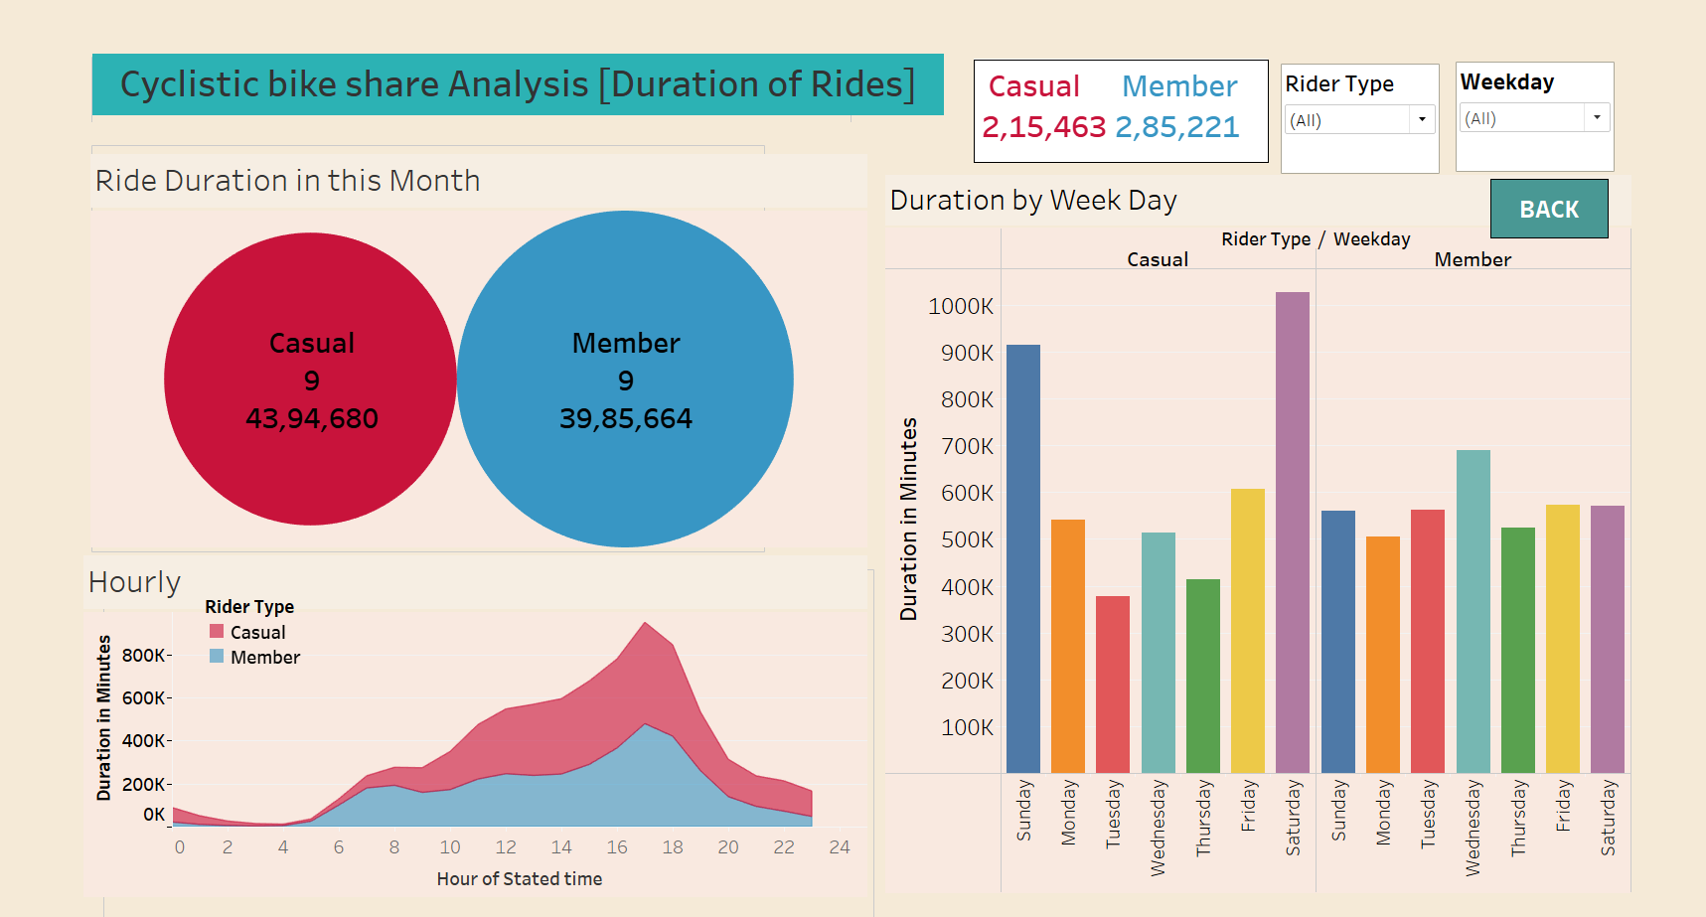

**Comparison between Docked Bike and Electric Bike**

* The most popular bike between both member is the Docked bike, followed by the electric bike.
* Both members Used Docked Bike more than the electric Bike
* Here given Duration rides, number of rides by the bike type

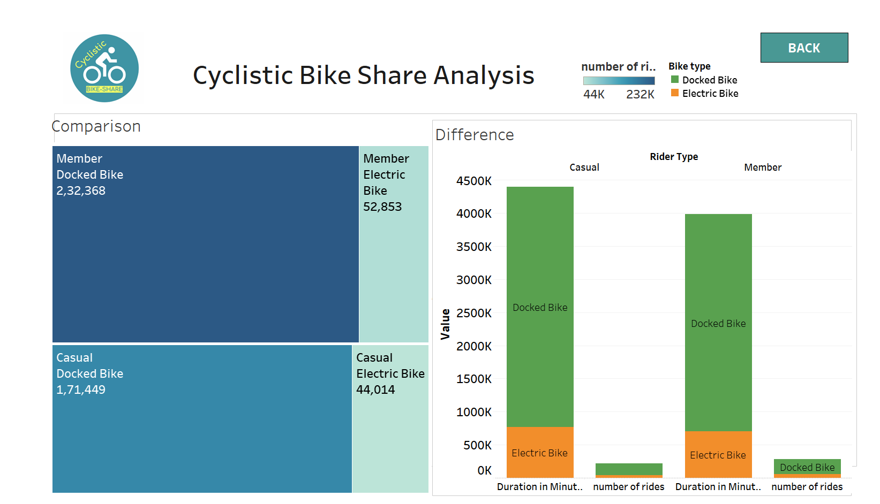

**Starting and Ending Busiest Station**

In this report the dark Area parts shows the busiest station of starting and ending.

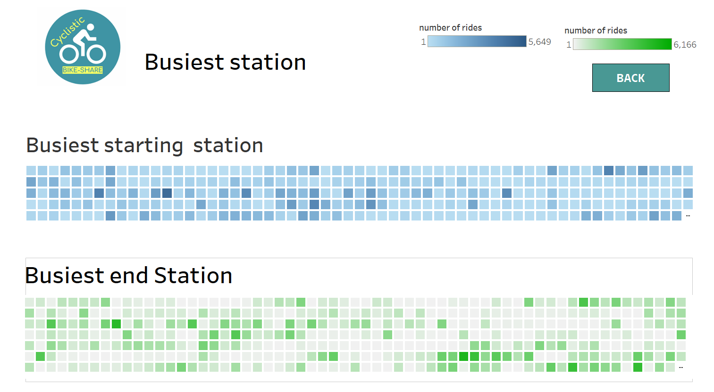

**The Top 10 Station**

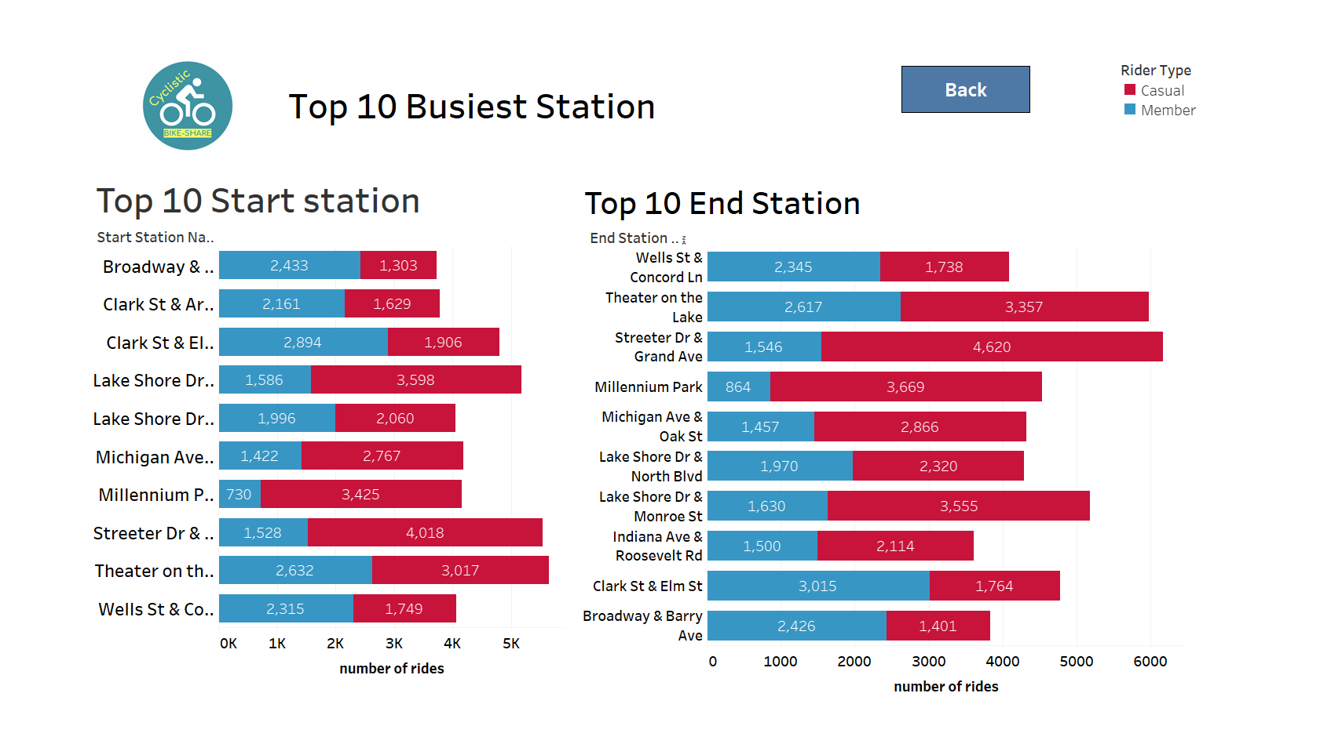

## **Recommendations**

Below are the 3 Recommendations that can help to convert Casual Riders into Annual members:

1. As we can extract from the data our current set of members are mostly those who use the service to commute to work or college. The upcoming marketing campaigns should focus on the other set of people who use the bikes for recreation (Casual Members). The recreational rides are often social where friends or family join together, so there can be a referral bonus if they make their friends and family sign up or a family plan for 2 or more people.
2. Bringing a Seasonal Pass can also greatly help with converting casual members into subscribers. The bikes are mostly used in summer and casual users might hesitate to commit to the annual membership as they use the bikes less in the winter.
3. Casual riders were also very active over the weekends, which presents an opportunity to design a weekend membership plan, and promotional rides that reflects this pattern of usage.

## **Conclusion**

Cyclistic Bike Share Analysis is my capstone project.

During the case study, I watched a lot of YouTube tutorials and did many Google searches to gather additional knowledge. It was taking 3 to 4 days to get knowledge about how to use the tools. Finaly, I have got some Knowledge.

In my project most difficult part is to clean the data